**How to set up PostgreSQL on Heroku and your Computer**

**PostgreSQL Database on your Computer**

1. Download and install PostgreSQL to your computer
   1. Guide (<https://www.postgresqltutorial.com/install-postgresql/>)
   2. Link to install (<https://www.enterprisedb.com/downloads/postgres-postgresql-downloads>)
2. Set up local server and create database to test locally
   1. Open pgAdmin4
   2. Click on “Add new Server”
   3. Complete values like in images below

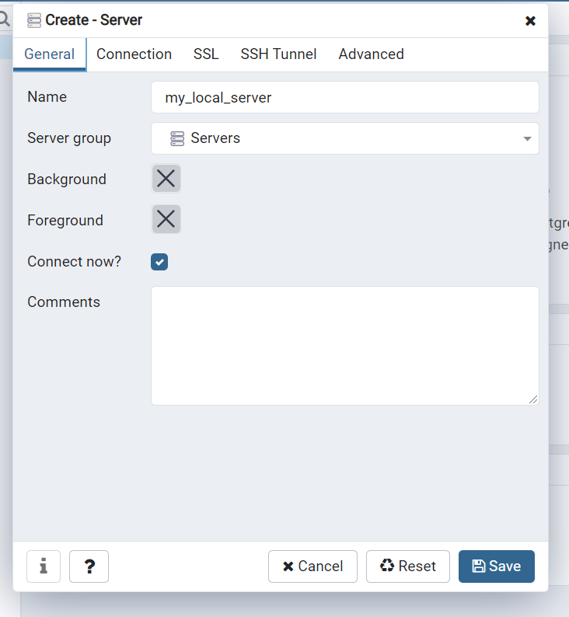

* 1. 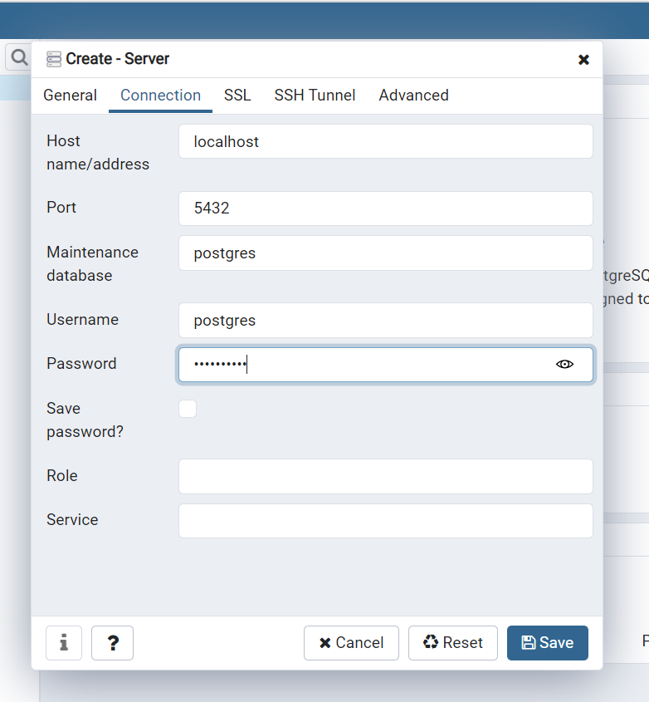
  2. Left side of page, click to open servers, then open my_local_server
  3. Right-click on databases(1), hit create…
  4. Call your database “test” and save

1. Create Table
   1. Open “test” database, open Schemas, right-click on Tables, and click on create table
   2. Name your table productlist, under “General” tab
   3. Go to “Columns” tab and create your columns, and save.

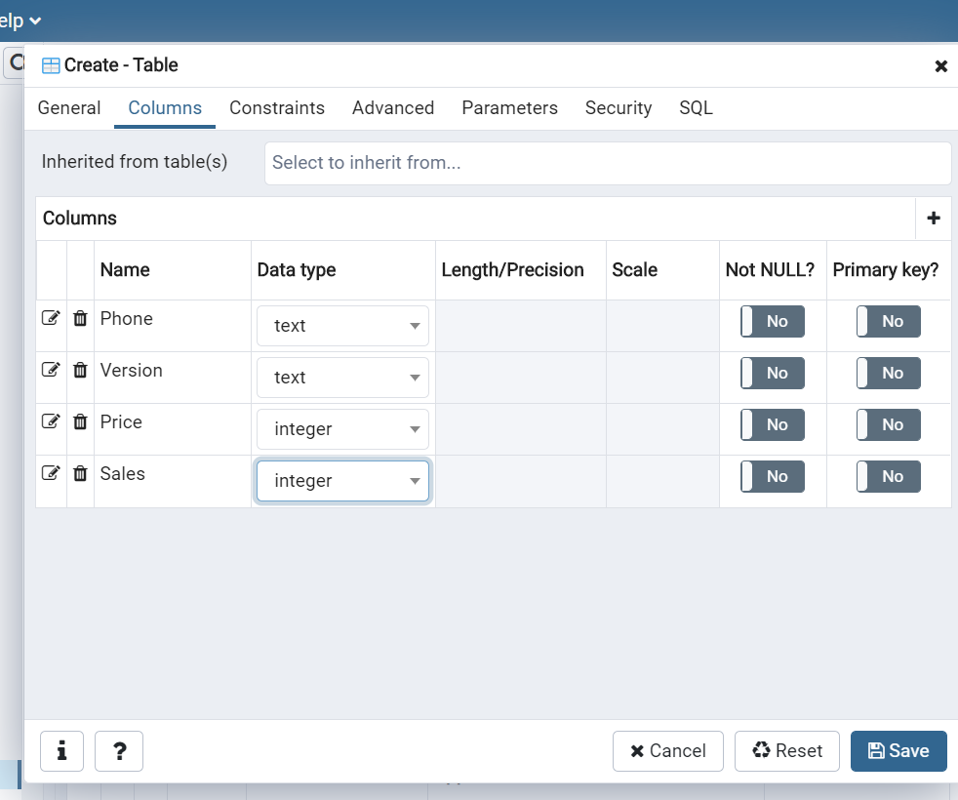

1. Add data to your new table:
   1. Right-click on your new table (productlist), click on import/export…
   2. Import filename should be your csv document, header==yes, delimiter= comma

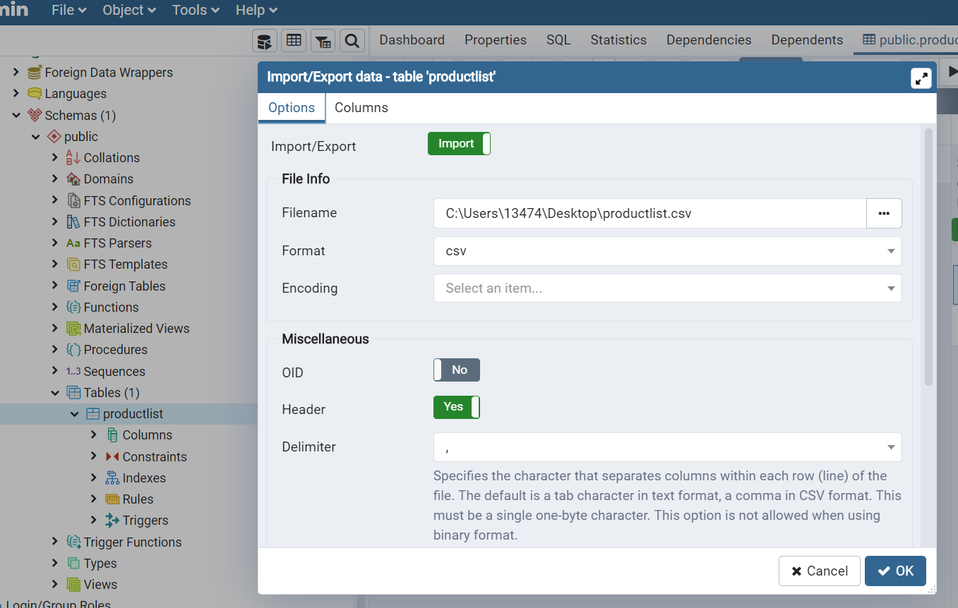

* 1. Right-click on Tables(1), click Refresh..,
  2. Right click on productlist, then click View/Edit Data

**PostgreSQL Database on your Heroku App**

1. Log into your Heroku account
2. Create new app on Heroku- call it “company-sales”
3. Click on Resources, and search for PostgreSQL under “Add-ons” section
4. Set up PostgreSQL by clicking on “Provision”
5. After it was created, go into postgresql database, click “Settings”, then click on “view credentials”
6. Open pgAdmin4 on your computer, upper left side of page, right-click on “servers”, then “create server”.
7. Under General, call it “heroku_pg_server”
8. Under Connection tab, the host name/address should be copy-paste of the Host value in step 9
9. The Maintenance Database value should be copy-paste of the Database value in step 9.
10. The Username value should be copy-paste of the User value in step 9
11. The password is the password value from step 9
12. Check the checkbox “save password?” and click to Save
13. Open “heroku_pg_server”; open Databases(),
14. Ctrl F and search for your database, using database value from step 9
15. Open database, open Schemas(1), then right-click on Tables, click on create table. Repeat step #3b and #3c and step #4 from the “**PostgreSQL on your Computer”** section above
16. Go back to your code; and inside your terminal type “pip install psycopg2” (this is a needed library for connecting to PostgreSQL)
17. Inside your code, add your Heroku database URI, found in step 9, to this line of code:

app.server.config["SQLALCHEMY_DATABASE_URI"] = “…”

1. Deploy your app to Heroku (my Youtube tutorial “Deploy your First App with Heroku and Dash Plotly” can help you do this step)
2. Enjoy 😊